

Department of Computer Science

MY University, Islamabad.

**Implementation Phase (LAB)**

**Project No: 04**

**Course Title: Database Systems**

**Student Name: Taha Saddiqui**

**Registration No: baib232005**

**Batch: Fall2023**

**Program: AI**

**Semester: 6th**

**Lab Instructor: Mr. Hamza Javed**

**Submission Date: 28/04/24**

 **DepartmentofComputerScience**

**Spring-2024 DataBase Systems (CS-103)**

Lab Task # 04

Data Definition Language (DDL) and Constraints

*Instructors: Mr. Hamza Javed*

*Date: 19 April 2023*

**Important Instruction**

1. No plagiarism allowed.
2. You will required to submit only soft copy via google classroom
3. Late submission not accepted
4. Rename submission file DB24-Name-RegNo. **like: DB24-hamza-1234**
5. You will required to submit single **pdf**

**Submission Example**

**Question .**

Write query to select all data from table:

Solution

SELECT * FROM db.detail;

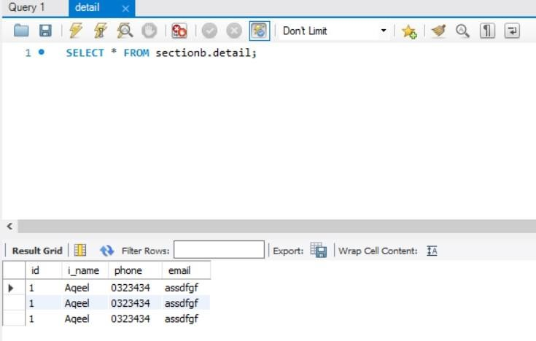

**Question 1**

# Tasks:1

1. **Create Department table based on the following design:**

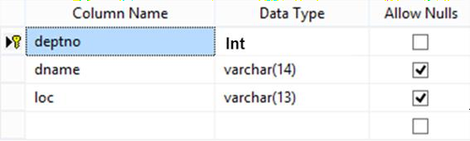

**Solution**

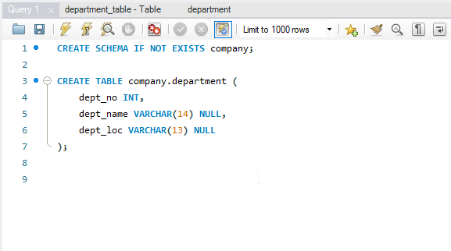

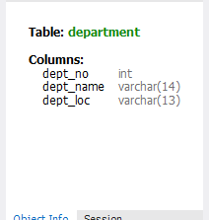

2

1. **Create Employee table based on the following design:**

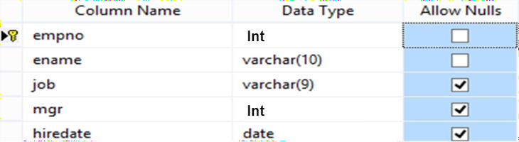

**Solution**

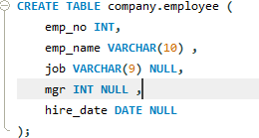

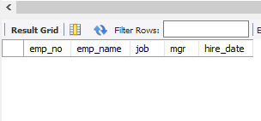

1. **Modify Employee table and add three more columns:**

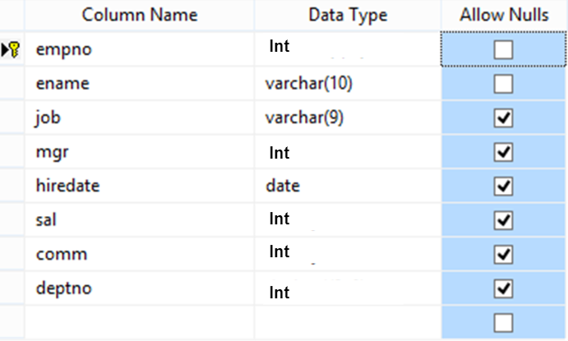

**Solution**

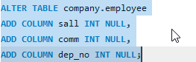

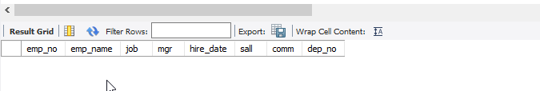

1. **Insert at least five Record into Employee table**

**Solution**

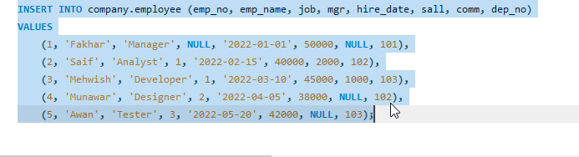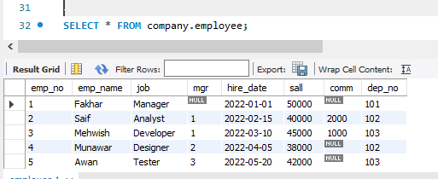

# Drop Column loc from Department table

**Solution**

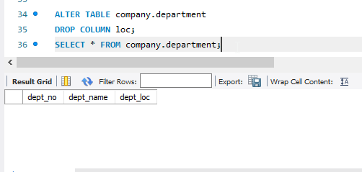

1. **Delete all record from Employee table**

**Solution**

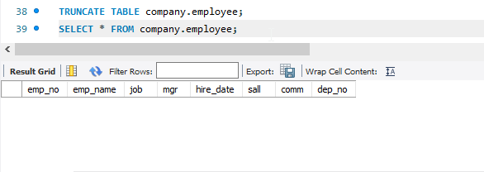

1. **Delete Department Table.**

**Solution**

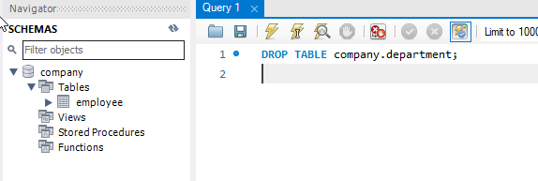

1. **Create database Authorization**

**Solution**

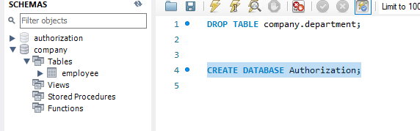

1. **Add a column ‘Address’ in Starsin table in database Authorization. CREATE TABLE StarsIn ( movieTitle char(30), movieYear int,starName char(30) );**

**Solution**

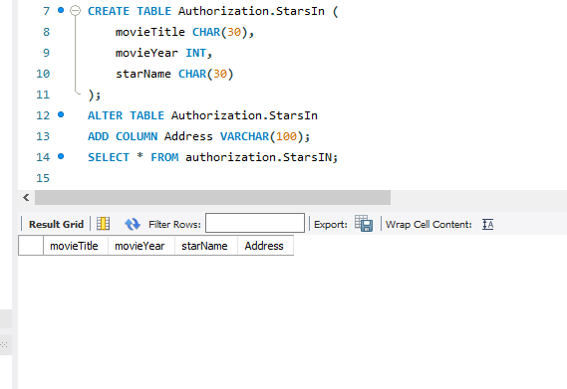

Question 2

Tasks:2

Solve the Queries given below according to the following tables given below:

**3**

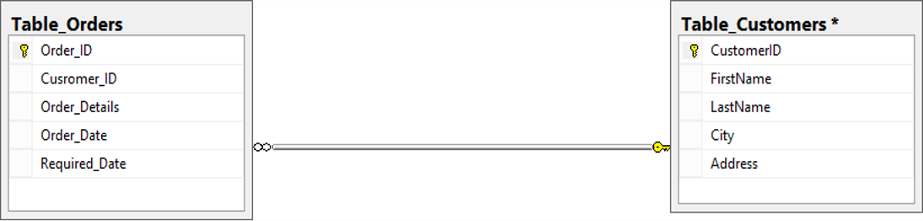

1. **Apply Not Null Constraint on all columns.**
2. **Apply primary key constraint in OrderID and customer ID**
3. **Apply foreign key constraint on Customer ID in Order table.**
4. **Apply check constraint on city (allow Karachi, Islamabad, Lahore only).**
5. **Set the default value of City as ‘Karachi’.**
6. **Add CNIC column in Customer table with unique constraint.**

Solution

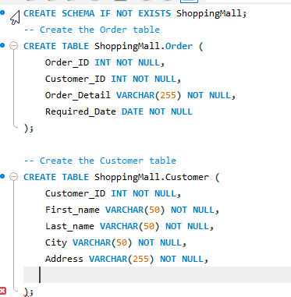

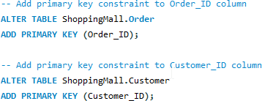

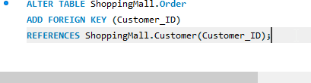

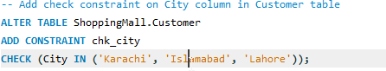

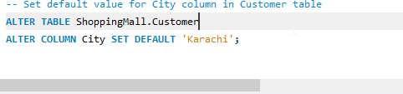

**Question 3**

Task:3

Create the following tables given in diagram with constraints (PK-FK relationship).

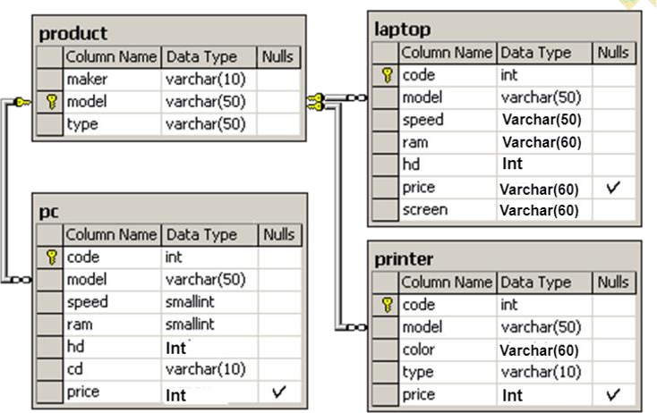

**Solution**

